American Diet

Introduction
Today most Americans are aware that a nutritious diet that is low in fat will lead to a longer and healthier life. To help Americans achieve this goal, the federal government develops dietary guidelines, which give advice about which foods Americans should eat to stay healthy.

Federal Dietary Guidelines
The U. S. Department of Agriculture and the U. S. Department of Health and Human Services release the Dietary Guidelines every five years. Nutrition experts, who study the dietary effects on health, have made recommendations to encourage certain dietary practices.
When first introduced in 1980, some people questioned the government’s ability to set nutrition guidelines. Government officials responded by saying that the rapid pace of scientific discovery makes it impossible for average Americans to stay abreast of the most recent information. Government guidelines provide at least a starting point.

Fat in the American Diet
A major emphasis of the guidelines is to encourage Americans to eat less fat. They recommend limits for total fat intake and saturated fat consumption. The guidelines stress the difference between saturated fats, which tend to raise blood cholesterol and unsaturated fats, which do not. Foods high in saturated fats include high-fat dairy products such as cheese, whole milk and ice cream as well as processed meats. Instead, choose unsaturated fat such as fish, nuts, olives, avocados and vegetable oils.

Recommended Dietary Guidelines for Americans
These following guidelines are general guidelines that every American should try to follow:
- Aim for a healthy weight
- Be physically active each day
- Let the food pyramid guide your food choices
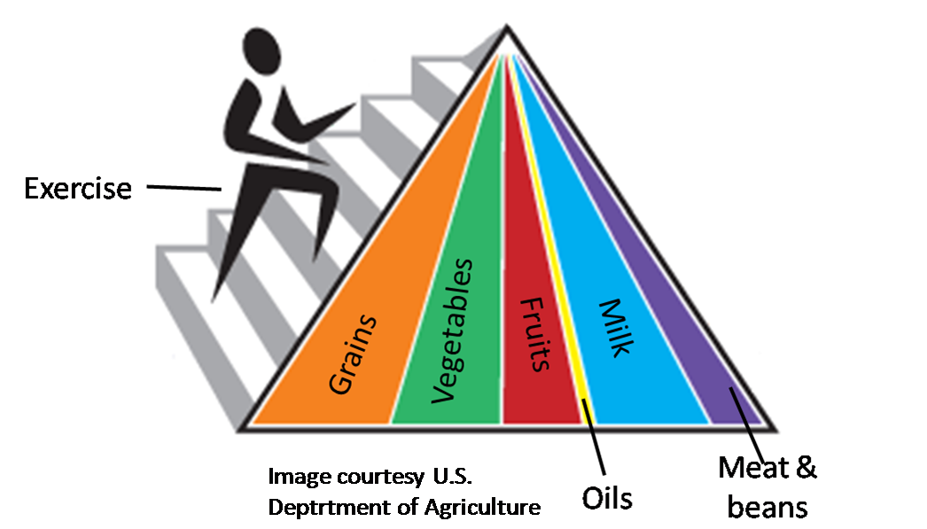
In addition, Americans should try to choose the following foods every day:
- A variety of grains daily, especially whole grains
- A variety of fruits and vegetables daily
- A diet that is low in saturated fats and cholesterol
- Beverages and food to moderate your intake of sugar
- Food with less salt
These guidelines are based on the new Food Pyramid.

They emphasize that moderate consumption is the key to good health. The guidelines also state that a person needs forty different nutrients for good health. No one food provides all the essential nutrients a body needs to stay healthy. Thus, the guidelines recommend that Americans eat a variety of foods from the major food groups.

References
2005 Dietary Guidelines Advisory Committee. 2005 Dietary Guidelines Advisory Committee Report. Washington: U.S. Government Printing Office, 2005.
Executive Office of the President and the Department of Health and Human Services. "Dietary Guidelines for Americans 2005." 12 January 2005. HealthierUS.gov. 25 May 2007 <www.healthierus.gov/dietaryguidelines>.
My Pyramid.gov. 8 March 2006. 25 May 2007 <www.mypyramid.gov/index.html>

