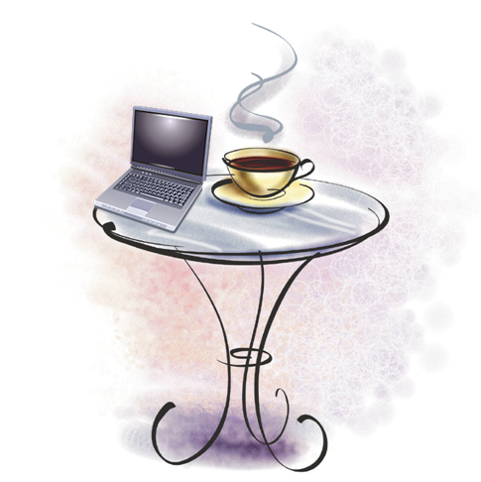
Java
Internet
Café
2001 Joliet Avenue
Boulder, CO 80302-2001
303.555.JAVA
JavaCafe@Cybershop.com

Java Internet Café offers customers computers with high-speed Internet access as well as free Wi-Fi. Each of our computers has a special interface for new users to allow you to get started exploring the World Wide Web. You have heard about it; now you need to try it! Ask your server to help you get started.

Menu

