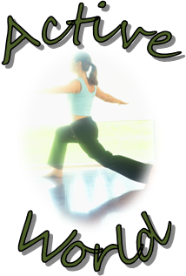

Welcome to Exercise World! As a new member, you can take advantage of our many programs, including classes in spinning and yoga and the use of a personal trainer. We think you’ll be pleased with all of the programs our club has to offer. We are the health club with something for everyone.
Please contact me if you have any questions.
Sincerely,

Josh Levasseur

